Name: _____________________________ (please print)
Signature: __________________________

ECE 3355 – Exam #1
October 3, 2024

Keep this quiz closed until you are told to begin.

- Print your name, and sign your name, at the top of this page.
- This exam is closed book, closed notes. You may use one 8.5” x 11” crib sheet, or its equivalent. You may use a calculator. You should not use a cell phone, tablet computer, or laptop computer, as you work on this exam.
- Show all work on these pages. You may use both sides of each page. Show all work necessary to complete the problem. A solution without the appropriate work shown will receive no credit. A solution which is not given in a reasonable order will lose credit.
- Show all units in solutions, intermediate results, and figures. Units in the quiz will be included between square brackets.
- Do not use red ink. Do not use red pencil.
- You will have 75 minutes to work on this exam.

- ________________/20

- ________________/40

- ________________/40
Room for extra work
- {20 Points} Assume that the input of an oscilloscope behaves as a 1[MΩ] resistor in series with a 370[μH] inductor. Design a compensated attenuator 10:1 oscilloscope probe that will give a display that does not distort the measurement of the signal being displayed on the screen. Show numerical values for the components in your design. Find the transfer function for your oscilloscope probe and the oscilloscope with the model given above.

Room for extra work

- {40 Points} Two amplifiers are connected in a circuit shown in Figure 1. One amplifier, called Device 1, has the equivalent circuit shown in Figure 2. The second amplifier, called Device 2, has the equivalent circuit shown in Figure 3. Note the terminal labels for the two amplifiers as they are connected in Figure 1, showing the positions of each terminal.
- Find v_{e} /v_{g}.
- Find the output resistance seen by R_{L}.

Room for extra work

- {40 Points} The straight-line approximation to the magnitude Bode plot for a circuit is shown in the plot below. The transfer function equation for this same circuit is given below.
- The numbers a, b, c, d, and e are all real numbers. Find their values, showing units where appropriate.
- Assume that K is a real number with a negative value. Plot the straight-line approximation to the phase Bode plot on the semi-log graph paper given on the next page. Two sheets are provided, in case you need more than one sheet.

Solution:
- {20 Points} Assume that the input of an oscilloscope behaves as a 1[MΩ] resistor in series with a 370[μH] inductor. Design a compensated attenuator 10:1 oscilloscope probe that will give a display that does not distort the measurement of the signal being displayed on the screen. Show numerical values for the components in your design. Find the transfer function for your oscilloscope probe and the oscilloscope with the model given above.
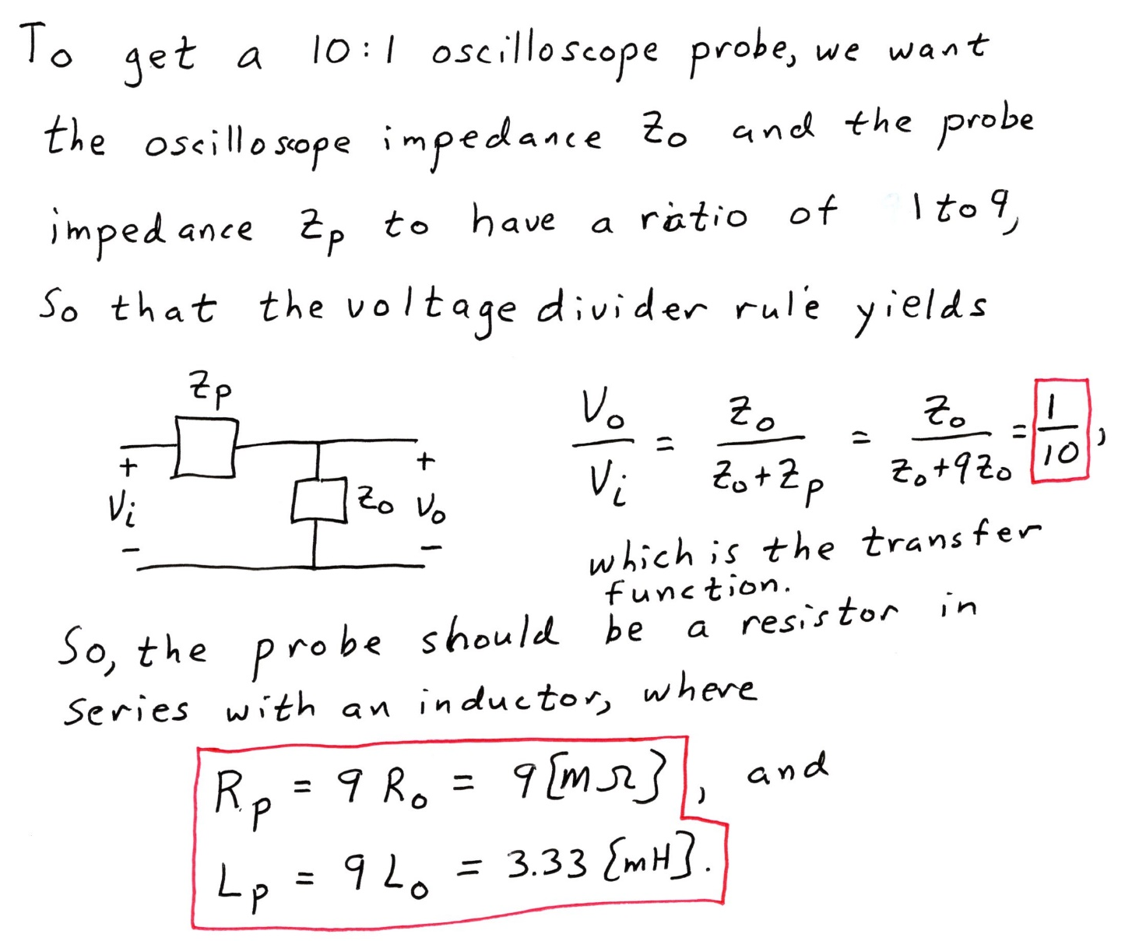

- {40 Points} Two amplifiers are connected in a circuit shown in Figure 1. One amplifier, called Device 1, has the equivalent circuit shown in Figure 2. The second amplifier, called Device 2, has the equivalent circuit shown in Figure 3. Note the terminal labels for the two amplifiers as they are connected in Figure 1, showing the positions of each terminal.
- Find v_{e} /v_{g}.
- Find the output resistance seen by R_{L}.

